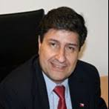 | Dr. Cristian Cardenas-Lailhacar, President  He is an Instructional Associate Professor in the Department of Mechanical and Aerospace Engineering at the University of Florida (UF) Herbert Wertheim College of Engineering, and an Affiliate Faculty in the UF Center for Latin American Studies. He serves as Assistant Director of both the UF Industrial Training and Assessment Center and the UF Mobile Energy Laboratory, for which he has completed over 420 assessments in the US and Latin America, including wastewater treatment plants (WWTP) in the State of Florida. He developed a study on the current energy use of these facilities that was used for performance improvement by the State. He has over 40 peer-reviewed publications, written 360 reports for the US-DOE, co-authored 3 books, and 4 chapters in books.
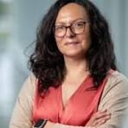 | Dr. Vinka Oyanedel-Craver, Vice-President and Treasurer  She is a Professor at the Department of Civil and Environmental Engineering at the University of Rhode Island. Her current research interests are in emerging contaminants of drinking water, wastewater, and stormwater treatment, as well as the development of novel water technologies. Her current research focus is on environmental nanotechnology, specifically on the behavior and application of nanomaterials in different ecological compartments and their use as antimicrobial compounds in point of use water/wastewater treatment in rural developing communities. Her research team has authored more than 45 peer-review publications.
 | Engineer Barbara Goldszier, Vice-President and Secretary  She is a Civil Engineer specializing in Water Engineering, graduated from the University of Buenos Aires. It has over 10 years of professional experience in water infrastructure projects, including work for Agua y Saneamientos Argentinos (AySA), the public water and sanitation utility serving the Buenos Aires metropolitan area.

